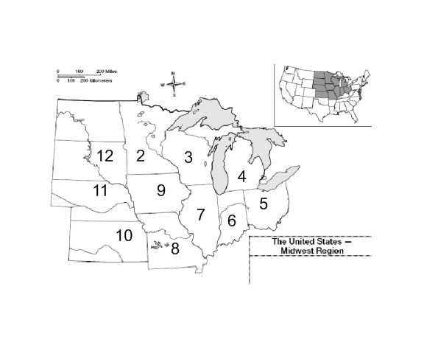
State Name State Capital
- _____________________ ___________________
- _____________________ ___________________
- _____________________ ___________________
- _____________________ ___________________
- _____________________ ___________________
- _____________________ ___________________
- _____________________ ___________________
- _____________________ ___________________
- _____________________ ___________________
- _____________________ ___________________
- _____________________ ___________________
- _____________________ ___________________

